Workday – Adding Goals for the year 2015-16
- Login to Workday (https://www.myworkday.com/csc/d/home.htmld) and click on “Personal Information” icon.
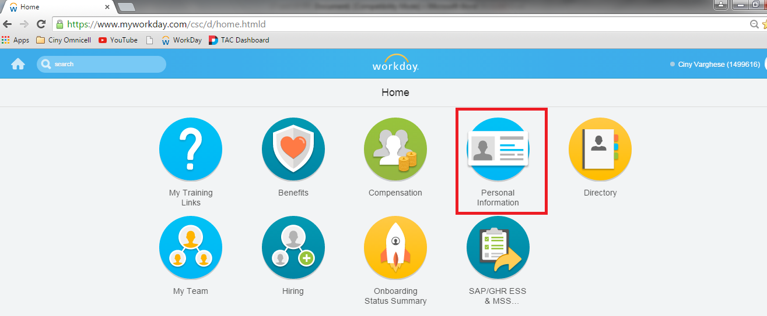
- In the “Personal Information” page, click on “About Me” under the View section.
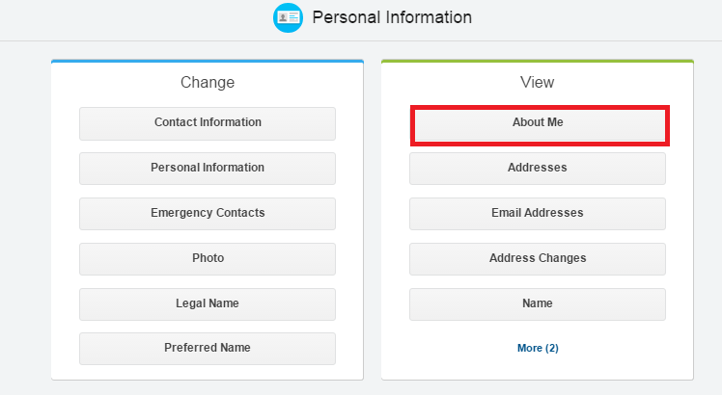
- Next, click on the “Performance” tab.
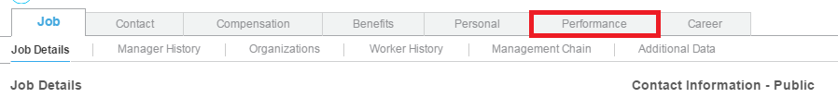
- In the “Performance Reviews” section, click on the “Goal Details” tab.
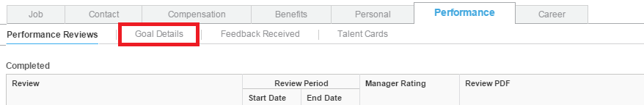
- In the Goal Section page, click on the “Edit” button in the “Not Started” row.
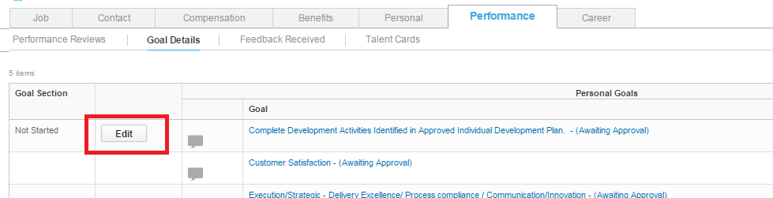
- Click on “Add” button”
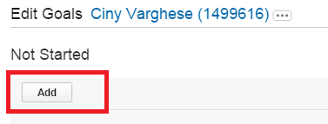
- Enter your Goal, Description, Due Date and Status
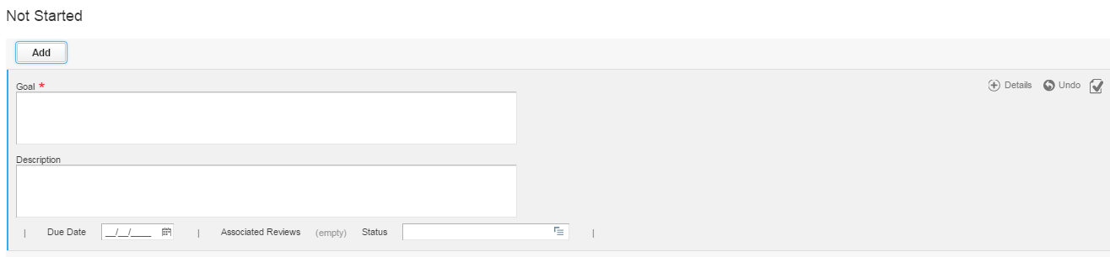
- Once you have entered all the details, click “Submit” button located at the bottom of the page. Next, click “Done” in the following page.
This completes the steps required to add the first goal. Follow steps 5-8 to add the remaining Goals.
NOTE: Once the Goals have been added, we can only change the Status of each of the goal using the Edit button.

